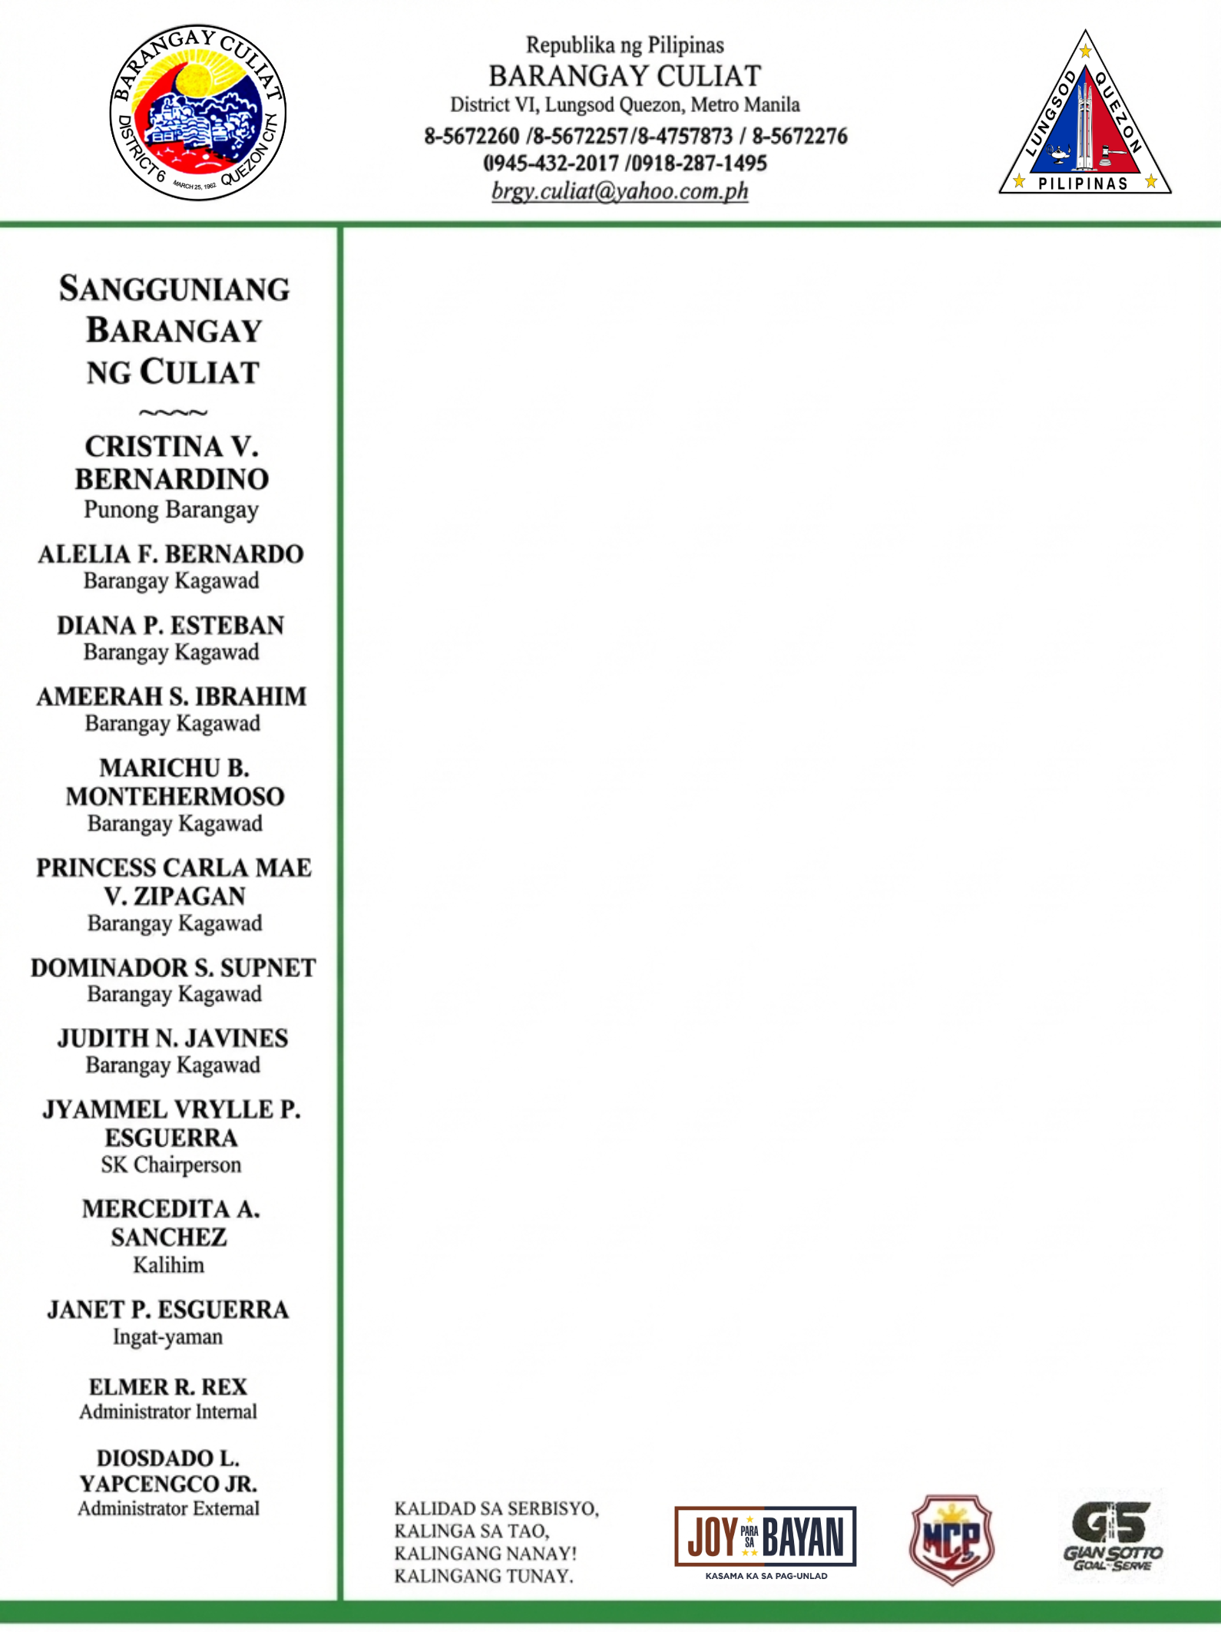

CERTIFICATE OF INDIGENCY

TO WHOM IT MAY CONCERN:

This is to certify that {salutation} {full_name}, Filipino, of legal age with postal address at {full_address}, Culiat, Quezon City, whose specimen signature appears below is a bona fide resident of this barangay.

This further certifies that the above-mentioned person belongs to the indigent families living in this barangay.

This certification is issued upon the request of {salutation} {last_name} for {purpose_of_request}.

Issued this {issue_date} at the office of the Punong Barangay, Culiat, District VI, Quezon City.



SCAN TO VERIFY
Control No : {control_number}
"This document is online generated at www.barangayculiat.com and is valid without a dry seal. Its authenticity can be verified through the official website using the QR code or the Control Number provided."

